**Pratical 5:** **Implement Xen virtualization and manage with Xen Center.**

1. Install **XenServer** in VMware Workstation and select Guest operating system as Linux.
2. Double click on the xen file.
3. Start the setup, choose location of the xen server
4. Click on install to install Xen Centre
5. Installing the server.
6. Click on finish to complete the installation.

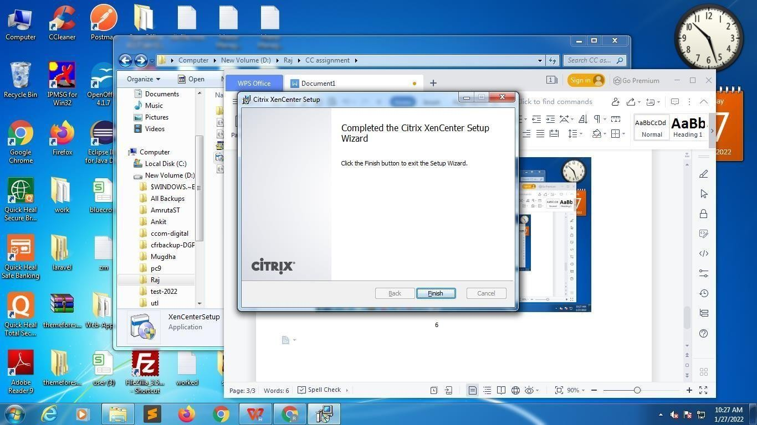

1. Open VM ware and Click on add new Server.

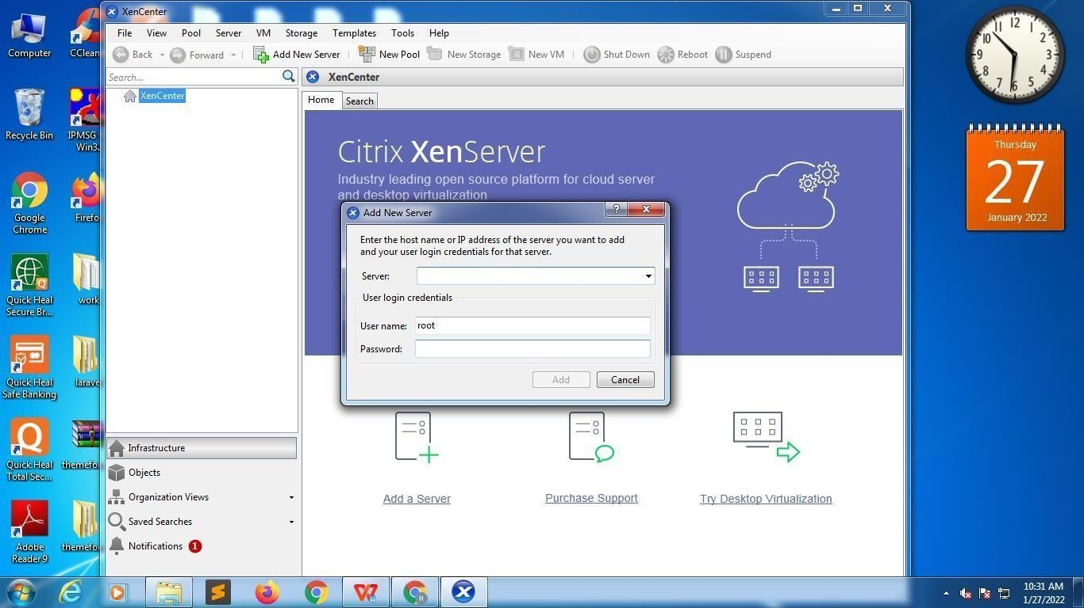

1. Add Server name as Xen Server, User name and password and click on add, your server will be added to the system. User name as <root= and Password as <root123= which we had given during installation and Click on Add.

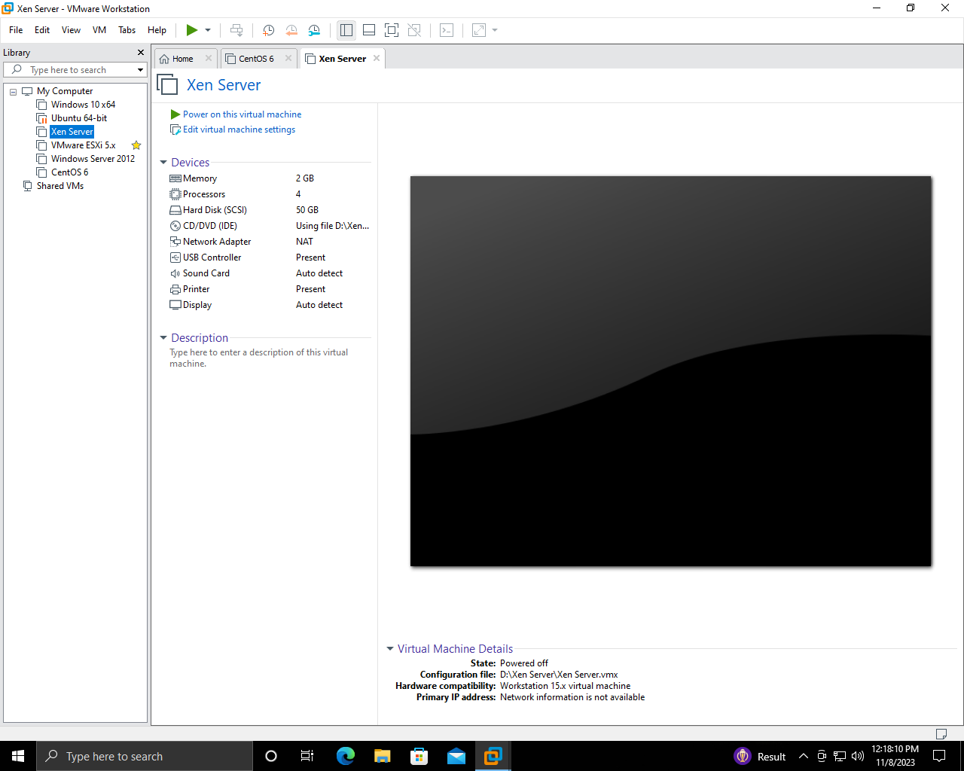

1. Click on Processors and check the first check box Virtualization Intel and click on OK.

# 

1. Click on CD/DVD and click on use ISO Image file radio button and select the location of XenServer where it is already installed and click on Ok.

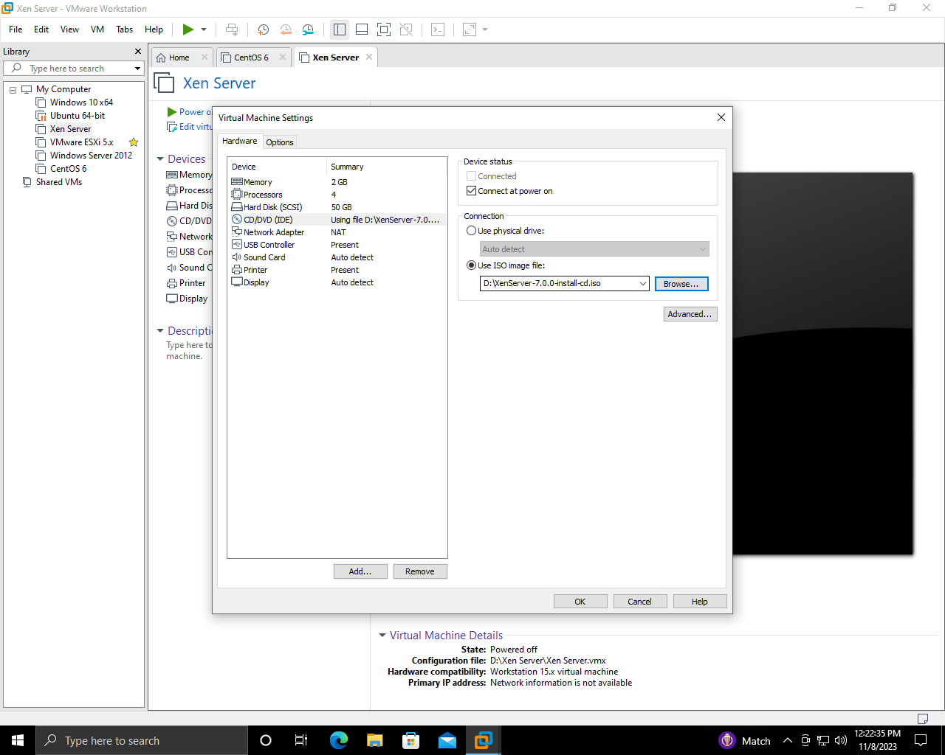

# Click on Power on This Virtual Machine.

# 

# Booting of Xen Server.

# 

# 

# Xen Server is Processing.

# 

# 

# Status and = IP address of Xen Server is displayed.

# 

# 